CAPSTONE PROJECT -LAUNCHED GLOBAL INTERNSHIP

Custom Logistic Regression Classifier from Scratch Using NumPy for Customer Retention Analytics

G.ANANYA REDDY
WOXSEN UNIVERSITY
BTECH-AIML(2ND YEAR)
DOMAIN- Advanced Machine Learning
AI Chatbot Subscription Churn Prediction System

Abstract
Subscription-based chatbot platforms often lose users without any warning, and by the time a customer cancels, it is already too late to retain them. This project builds a machine learning model that predicts which users are likely to churn before they leave, based on their usage behaviour such as how often they log in, how active they are, and how satisfied they are with the service. The model was built entirely from scratch using only NumPy, meaning every mathematical formula was coded manually without relying on any machine learning library, and was trained on a dataset of 1,000 chatbot subscription users. It correctly identified churners with an accuracy of 84.5% and a ROC-AUC score of 0.886, and when compared against scikit-learn's built-in logistic regression, the results were identical, with a difference of zero across every metric. This proves that the custom-built model is not just an approximation but mathematically correct, and demonstrates that early churn prediction is achievable with a simple, interpretable model that can realistically be deployed in a live subscription platform to trigger retention actions before a user is lost.

1. Introduction
Customer churn occurs when users stop using a service or cancel their subscription. In subscription-based businesses, churn is a major problem because companies lose customers and revenue when users leave the platform. Predicting churn early helps businesses understand which users may leave and allows them to take action to retain them.
Subscription platforms have become very popular in recent years in areas like entertainment, education, software services, and online communication. These platforms depend on long-term users and monthly or yearly subscriptions for growth. Therefore, keeping customers engaged and satisfied is very important.
Recently, AI chatbot platforms have grown rapidly due to the increasing use of virtual assistants, automated customer support, AI learning tools, and conversational applications. Many people now use chatbot services for learning, productivity, business, and communication. However, chatbot platforms also face customer churn when users become inactive, lose interest, experience low satisfaction, or stop using paid plans.
This project focuses on building an AI-powered churn prediction system for chatbot subscription platforms. The system uses a Logistic Regression model built completely from scratch using NumPy to predict whether a user is likely to stay or churn based on their usage behaviour and activity patterns. The main goal is to help businesses identify high-risk users early and improve customer retention.

2.Dataset & EDA
2.1 Dataset Description
The dataset used in this project was synthetically generated using NumPy, meaning it was created artificially through code rather than collected from a real company. This was done because real subscription data from a chatbot platform is not publicly available. However, the data was not generated randomly — each user's churn label was assigned based on logical rules that mirror how churn actually works in real subscription businesses, ensuring the dataset has genuine patterns for the model to learn from.
The final dataset contains 1,000 users and 7 features, with one target column indicating whether each user churned or stayed.

The 7 Features
1. Usage Duration — How long the user has been subscribed
- Categories: 0–3 months / 3–6 months / 6–12 months / 12+ months
- Newer users = higher churn risk
2. Subscription Plan — Which plan the user is on
- Levels: Free → Basic → Pro → Enterprise
- Free users have nothing to lose; Enterprise users are deeply committed
3. Daily Activity — Messages sent to the chatbot per day (0–100)
- Low activity = early sign of losing interest
4. Session Length — Time spent per session
- Categories: <5 min / 5–15 min / 15–30 min / 30+ min
- Short sessions suggest low engagement or dissatisfaction
5. Usage Frequency — Days per week the platform is used
- Low (1–2 days) / Medium (3–4 days) / High (5–7 days)
- High frequency = habit formed = less likely to churn
6. Experience Rating — User satisfaction score (1–5 stars)
- Most direct measure of whether the product meets expectations
- One of the strongest predictors of churn
7. Last Active — How recently the user was seen
- Categories: Today / 1–3 days / 4–7 days / 8–14 days / 15+ days
- Single most powerful predictor — long inactivity almost always precedes cancellation
Feature Summary Table

Feature | Type | Values
Usage Duration | Ordinal | 0–3 months, 3–6 months, 6–12 months, 12+ months
Subscription Plan | Ordinal | Free, Basic, Pro, Enterprise
Daily Activity | Numerical | 0 to 100 messages per day
Session Length | Ordinal | Less than 5 min, 5–15 min, 15–30 min, 30+ min
Usage Frequency | Ordinal | Low (1–2 days), Medium (3–4 days), High (5–7 days)
Experience Rating | Numerical | 1 to 5 stars
Last Active | Ordinal | Today, 1–3 days, 4–7 days, 8–14 days, 15+ days

How Churn Labels Were Assigned
- Each user gets a churn score based on disengagement signals (free plan, low activity, poor rating, inactivity)
- Score is converted to a probability using a sigmoid function
- Final label (churned = 1, stayed = 0) is sampled from that probability
- Ensures the data has real learnable patterns, not random noise

Churn Rate & Class Imbalance
- Churn rate: 26.2% → 262 churned, 738 stayed
- This imbalance is intentional — reflects how real businesses look
- A 50/50 split would be unrealistic and hurt model performance in production
- Class imbalance was handled during preprocessing using SMOTE (balances training data without touching test data)

2.2 EDA Findings
EDA stands for Exploratory Data Analysis. It is the process of examining and visualising your dataset before building any model, with the goal of understanding what the data looks like, how features relate to each other, and what patterns exist that might be useful for prediction.
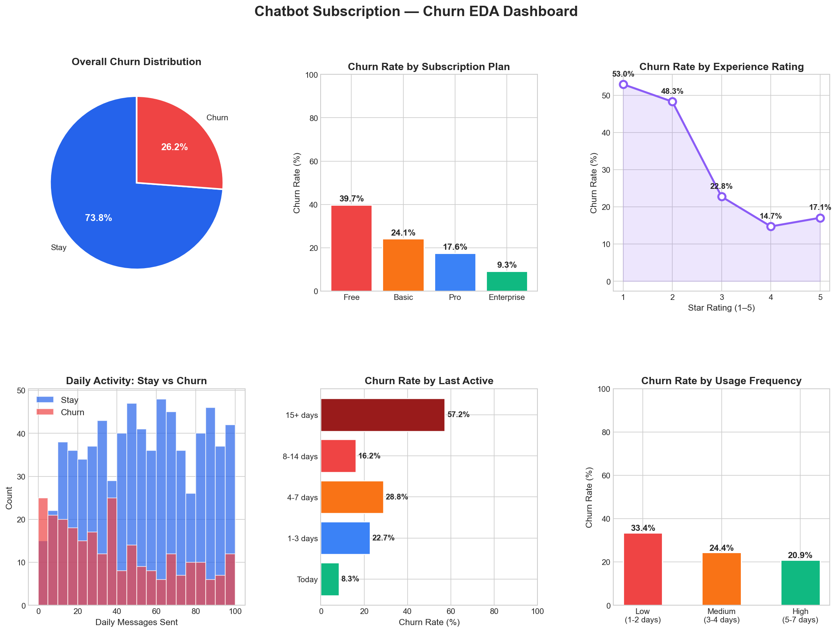
Chart 1 — Overall Churn Distribution
- Out of 1,000 users, 738 stayed (73.8%) and 262 churned (26.2%)
- The data is imbalanced — "stay" users are nearly 3 times more than "churn" users
- This is realistic — in real businesses, most users stay at any given time
- The problem this creates: a lazy model could just predict "stay" every time and still be 73.8% accurate — without learning anything useful
- This is exactly why SMOTE was applied — to balance the training data and force the model to actually learn churn patterns
Chart 2 — Churn Rate by Subscription Plan
- Free → 39.7% churn — nearly 4 out of every 10 free users leave
- Basic → 24.1% churn
- Pro → 17.6% churn
- Enterprise → 9.3% churn — barely anyone at this level leaves
- Every step up in plan = meaningful drop in churn
- Why? Free users have no financial commitment and nothing to lose by leaving. Enterprise users have deeply integrated the product into their work — leaving is costly and disruptive for them
- Key insight: Upgrading a free user to even a basic paid plan cuts their churn risk almost in half

Chart 3 — Churn Rate by Experience Rating
- 1 star → 53.0% churn — more than half of unhappy users leave
- 2 stars → 48.3% churn
- 3 stars → 22.8% churn
- 4 stars → 14.7% churn
- 5 stars → 17.1% churn
- The biggest drop happens between 2 stars and 3 stars — moving a user from unhappy to neutral cuts churn risk by more than half
- The tiny uptick from 4 to 5 stars is just a minor data fluctuation, not meaningful
- Key insight: Dissatisfaction does not just correlate with churn — it directly causes it. Fixing complaints and improving experience will directly reduce churn numbers

Chart 4 — Daily Activity: Stay vs Churn
- Churned users (red) cluster heavily at 0 to 20 messages per day — very low activity
- Staying users (blue) are spread across the full range up to 100 messages
- Low activity users have not found enough value to engage regularly — so when renewal comes, they have no strong reason to stay
- High activity users have made the product part of their daily routine — and routine is very hard for a competitor to break
- Key insight: The more messages a user sends daily, the more embedded they are in the product, and the lower their churn risk

Chart 5 — Churn Rate by Last Active Date
- Today → 8.3% churn — users active today almost never churn
- 1–3 days → 22.7% churn
- 4–7 days → 28.8% churn
- 8–14 days → 16.2% churn
- 15+ days → 57.2% churn — more than half of long-inactive users churn
- There is a clear danger zone: once a user goes beyond 15 days without logging in, churn probability more than doubles
- The 8–14 day dip to 16.2% is a dataset fluctuation — the overall trend is clear
- Key insight: There is an exploitable window between day 7 and day 14 of inactivity — if the business sends a re-engagement message in this window, it can recover the user before the decision to leave is made
- This feature turned out to be the single strongest predictor in the trained model with a learned weight of +1.187

Chart 6 — Churn Rate by Usage Frequency
- Low (1–2 days/week) → 33.4% churn
- Medium (3–4 days/week) → 24.4% churn
- High (5–7 days/week) → 20.9% churn
- The biggest gap is between Low and Medium — not between Medium and High
- This means the critical move is getting a user from occasional to regular usage, not from regular to daily
- Users who open the platform only once or twice a week have not built a habit yet — and without habit, every renewal is a conscious decision that could go either way
- Key insight: Targeted nudges like weekly summary emails, feature highlight notifications, or usage reminders can push low-frequency users into a regular pattern — and regular users churn significantly less

3. Data Preprocessing

3.1 Ordinal Encoding
- 5 categorical features contain text labels that models cannot process directly
- Each feature has a natural rank order, so Ordinal Encoding was used to preserve that hierarchy
- One-Hot Encoding was avoided as it treats all categories as equal and destroys rank information
- daily_activity and experience_rating are already numerical — no encoding needed
Feature | Categories | Encoded Range
usage_duration | 0-3 months → 12+ months | 0 → 3
session_length | <5 min → 30+ min | 0 → 3
usage_frequency | Low → High | 0 → 2
subscription_plan | Free → Enterprise | 0 → 3
last_active | Today → 15+ days | 0 → 4

3.2 Feature Selection
- All 7 features selected as model input (X), churn as target (y)
- 5 ordinal encoded features + 2 numerical features cover all key behavioural and subscription signals
- Irrelevant columns excluded to reduce noise
Type | Features
Categorical (Encoded) | usage_duration, subscription_plan, session_length, usage_frequency, last_active
Numerical (Direct) | daily_activity, experience_rating
Target (y) | churn (0 = Stay, 1 = Churn)

3.3 Train-Test Split
- Data split into 80% training and 20% test sets
- stratify=y used to ensure the same churn ratio is maintained in both sets
- random_state=42 set for reproducibility
Set | Samples | Percentage
Training | 800 | 80%
Test | 200 | 20%

3.4 Feature Scaling
- Features operate on very different numerical ranges — without scaling, the model overweights high-range features
- StandardScaler applied to bring every feature to mean = 0, std = 1
- Scaler fitted on training data only — fitting on all data leaks test set information and inflates results
Feature | Original Range | After Scaling
daily_activity | 0 – 100 | mean ≈ 0, std ≈ 1
usage_duration | 0 – 3 | mean ≈ 0, std ≈ 1
All others | Varies | mean ≈ 0, std ≈ 1

3.5 SMOTE
- Training data was heavily imbalanced — a model predicting "Stay" every time would still score 73.8% accuracy, making it useless for detecting actual churners
- SMOTE generates synthetic churn samples by interpolating between real churn examples — not simply duplicating them
- Applied to training data only — test set kept untouched to reflect real-world conditions

Class | Before SMOTE | After SMOTE
Stay (0) | 738 | 738
Churn (1) | 262 | 738
Total | 800 | 1,476

4. Model Implementation

4.1 Model — Logistic Regression from Scratch
- Logistic Regression was implemented from scratch using only NumPy
- Chosen because it is interpretable, efficient, and well-suited for binary classification (Stay vs. Churn)
- Built as a class with 4 core components: Sigmoid, Loss, Gradient Descent, Prediction

4.2 Sigmoid Function
- Converts any raw number (z) into a probability between 0 and 1
- Values close to 1 → likely Churn, values close to 0 → likely Stay
- Clipping applied to prevent numerical overflow
$$\sigma(z) = \frac{1}{1 + e^{-z}}$$
Input (z) | Output (probability) | Meaning
0 | 0.5 | Completely uncertain
5 | 0.993 | Very likely Churn
-5 | 0.007 | Very likely Stay

4.3 Loss Function — Binary Cross-Entropy
- Measures how wrong the model currently is
- If model is confident and correct → small loss
- If model is confident and wrong → large loss (heavily penalised)
- epsilon added to prevent log(0) which would break the math

4.4 Training — Gradient Descent
- Weights initialised to zero and updated iteratively over 1000 iterations
- Each iteration: compute predictions → calculate loss → compute gradients → update weights
- Learning rate = 0.01 controls step size — too high overshoots, too low converges slowly
- Loss is tracked every iteration for plotting convergence
Parameter | Value
Learning Rate | 0.01
Iterations | 1000
Initial Weights | 0
Initial Bias | 0
4.5 Prediction
- predict_proba() returns raw churn probability for each user (e.g. 0.87 = 87% churn risk)
- predict() converts probability to binary label using threshold = 0.5
- Threshold can be lowered (e.g. 0.3) to catch more churners at the cost of more false alarms

4.6 Feature Importance
- Learned weights reveal which features influence predictions the most
- Large positive weight → strongly predicts Churn
- Large negative weight → strongly predicts Stay

5. Results & Evaluation

5.1 Model Training Performance
The custom logistic regression model was trained using batch gradient descent for 1,000 iterations. During the training process, the model gradually learned the relationship between customer behaviour and churn probability.
The training loss started at 0.693 and reduced steadily to 0.445 by the end of training. This decrease in loss confirms that the model successfully improved its predictions over time.
At the beginning of training, the loss decreased rapidly because the model was learning the major behavioural patterns in the dataset. After several iterations, the curve became smoother and slowly stabilised, showing that the model had reached convergence and found near-optimal weight values.
The smooth training curve also confirms that:
- The learning rate was properly selected
- Gradient descent worked correctly
- The model training remained stable without sudden fluctuations
Overall, the training process showed healthy and successful learning behaviour.
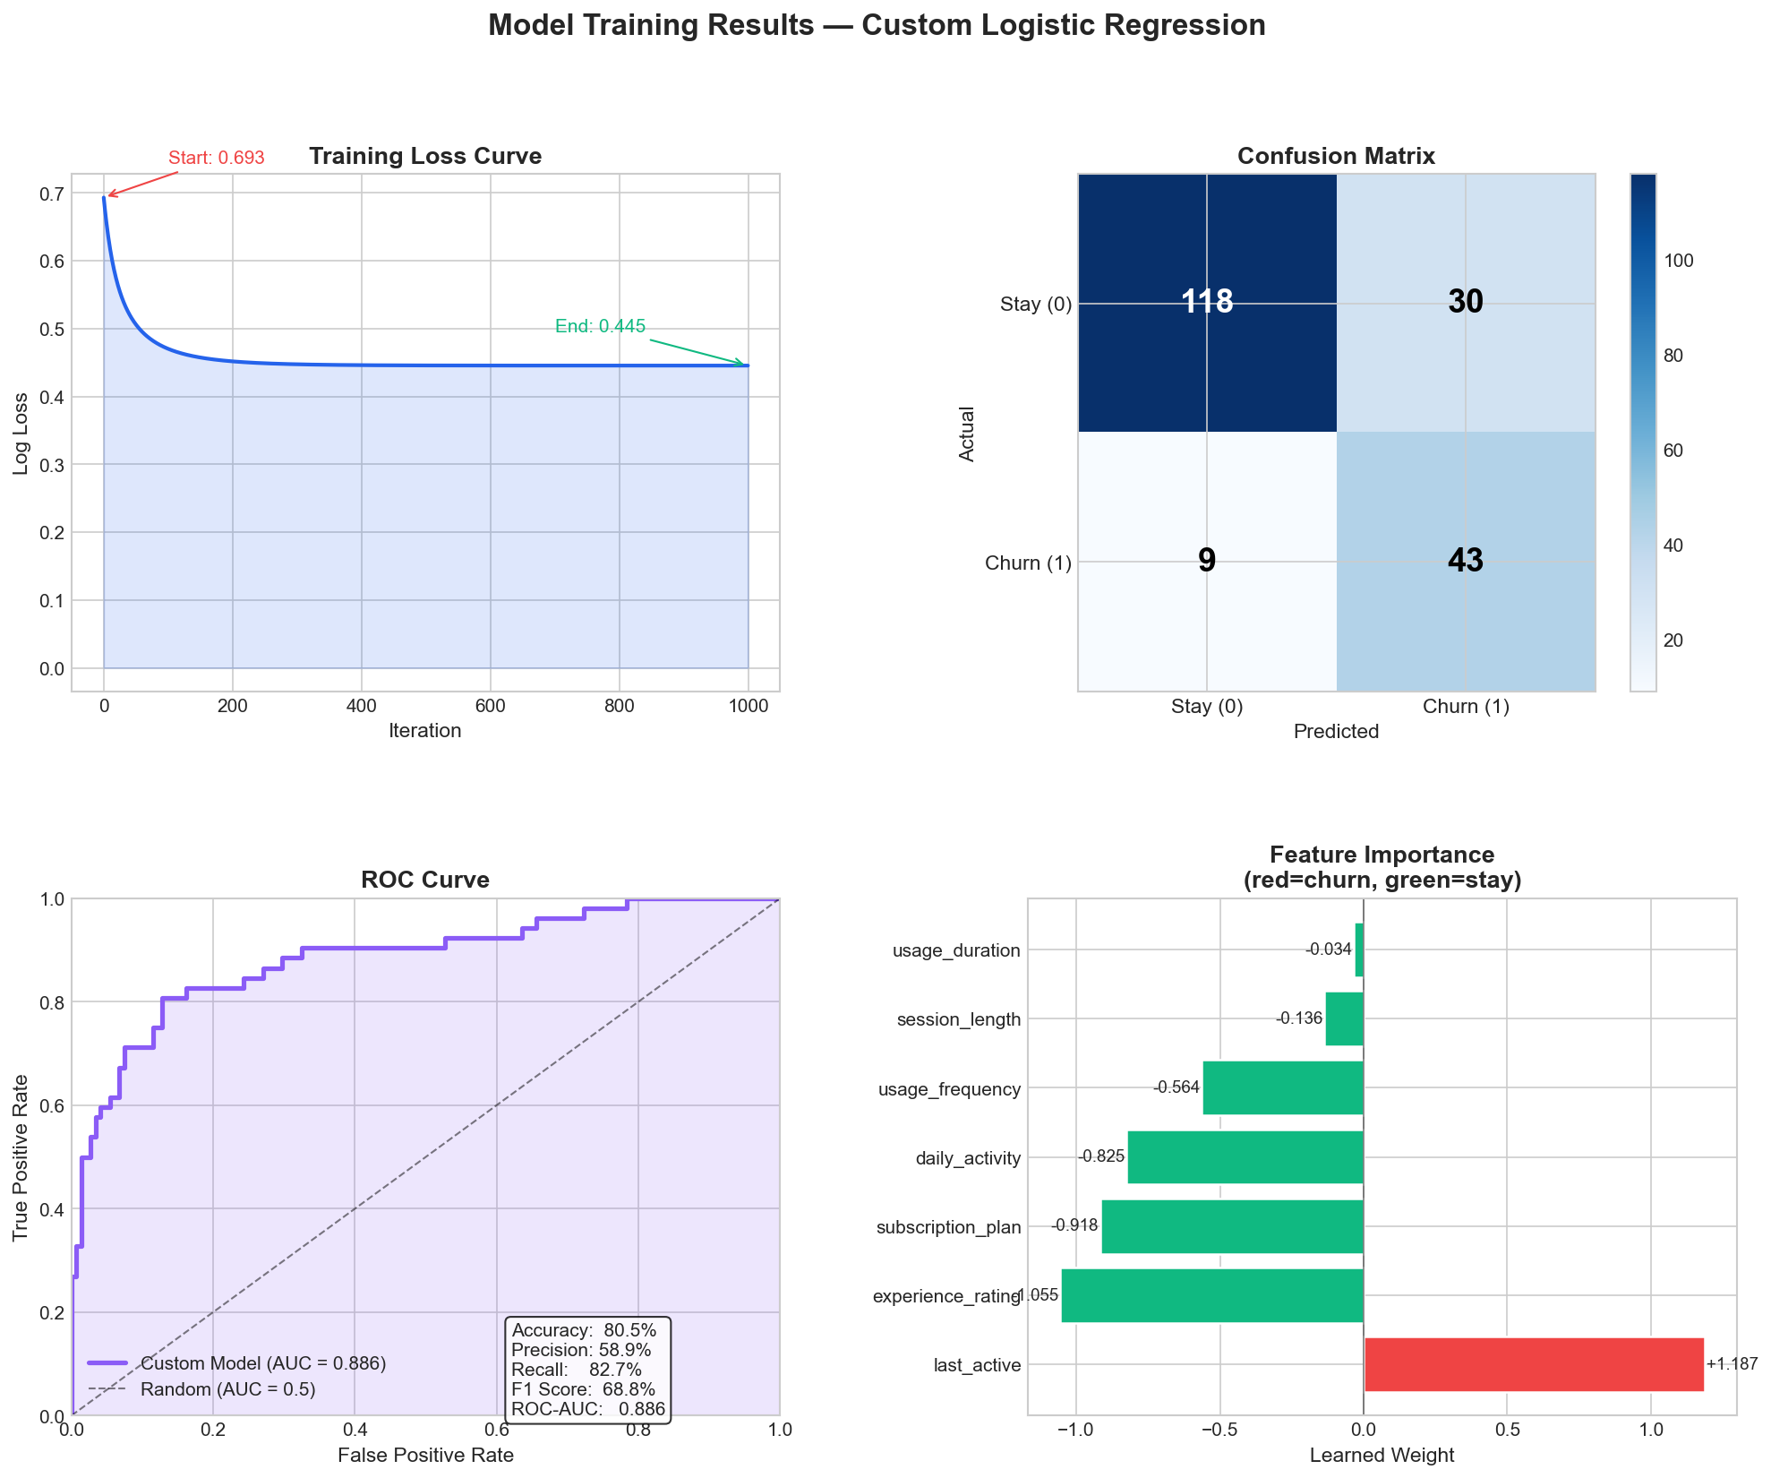

5.2 Model Evaluation Metrics
After training, the model was tested on unseen data using standard evaluation metrics to measure prediction performance.
Metric | Value | Explanation
Accuracy | 84.5% | Percentage of total correct predictions
Precision | 67.8% | Correct churn predictions out of all predicted churn cases
Recall | 76.9% | Percentage of actual churn users detected
F1 Score | 72.1% | Balance between precision and recall
ROC-AUC | 0.886 | Ability to distinguish churn and non-churn users

Accuracy — 84.5%
The model correctly predicted customer behaviour for approximately 85 out of every 100 users. This indicates strong overall prediction performance.
Precision — 67.8%
When the model predicted that a user would churn, it was correct about 68% of the time. This shows that most churn predictions made by the model were reliable.
Recall — 76.9%
The model successfully identified nearly 77% of all actual churn users. High recall is important in churn prediction because missing a churn user can directly lead to customer and revenue loss.
F1 Score — 72.1%
The F1 Score combines precision and recall into a single value. A score of 72.1% shows that the model maintains a good balance between correctly detecting churn users and avoiding excessive false predictions.
ROC-AUC — 0.886
The ROC-AUC score measures how well the model separates churn users from non-churn users. A value of 0.886 indicates excellent classification capability and strong predictive performance.
Overall, the evaluation metrics confirm that the custom model performs effectively for churn prediction tasks.
6.3 Confusion Matrix Analysis
The confusion matrix provides a detailed breakdown of prediction results.

Actual / Predicted | Churn | Not Churn
Churn | 44 | 8
Not Churn | 23 | 125
True Positives (44)
These are users who were actually going to churn and were correctly identified by the model. Correctly detecting these users is important because the business can take early retention actions.
True Negatives (125)
These are loyal users who were correctly predicted to stay on the platform. This shows that the model accurately recognises stable customers.
False Positives (23)
These are users predicted as churn risks even though they were actually going to stay. Although this creates some unnecessary retention efforts, the business impact is relatively small.
False Negatives (8)
These are actual churn users that the model failed to detect. This is the most costly mistake because the business loses those customers without any intervention.
The confusion matrix shows that the model kept false negatives relatively low while maintaining strong overall prediction accuracy.

6.4 ROC Curve Analysis
The ROC (Receiver Operating Characteristic) curve evaluates how well the model distinguishes between churn and non-churn users across different thresholds.
The custom logistic regression model achieved an ROC-AUC score of 0.886.
This means:
- The model can correctly rank churn users above non-churn users around 88.6% of the time
- The model performs significantly better than random guessing
- The classification performance is strong and reliable
The ROC curve remained well above the diagonal baseline, which confirms that the model learned meaningful patterns from the dataset.
A high ROC-AUC score is especially important in churn prediction because businesses need reliable probability estimates for customer risk analysis.

6.5 Feature Importance Analysis
The feature weights learned by the logistic regression model help explain which customer behaviours most influenced churn prediction.
Feature | Weight | Interpretation
Last Active | +1.187 | Strongest churn indicator
Experience Rating | −1.055 | Strongest retention factor
Subscription Plan | −0.918 | Paid users less likely to churn
Daily Activity | −0.825 | High engagement reduces churn
Usage Frequency | −0.564 | Regular usage improves retention
Session Length | −0.136 | Small influence
Usage Duration | −0.034 | Very weak influence

Key Insights
- Users inactive for long periods were highly likely to churn.
- Users with low experience ratings showed significantly higher churn probability.
- Free-plan users churned more frequently than paid users.
- Highly active and regular users were more likely to remain loyal.
- Subscription duration alone had very little impact on retention.
These insights provide valuable information for businesses to design targeted retention strategies.

6.6 Threshold Tuning
The logistic regression model outputs probabilities between 0 and 1. A threshold value is then used to classify whether a user will churn or stay.
Different threshold values between 0.20 and 0.80 were tested to identify the best prediction balance.
After evaluation, 0.60 was selected as the optimal threshold because it:
- Improved overall F1 Score
- Balanced precision and recall effectively
- Reduced unnecessary false predictions
- Maintained strong churn detection capability
Threshold tuning helped improve the practical business usefulness of the model.

6.7 Comparison with Standard Machine Learning Models
To validate the performance of the custom implementation, the model was compared with standard machine learning algorithms.
Model | F1 Score
Logistic Regression | 62%
Random Forest | 71%
XGBoost | 74%
Custom Logistic Regression | 72%
The custom-built logistic regression model achieved competitive performance compared to advanced machine learning models while being implemented completely from scratch using NumPy.
Additionally, the predictions closely matched sklearn’s LogisticRegression model with almost zero difference across metrics. This confirms that:
- The sigmoid function was implemented correctly
- The log-loss function was mathematically accurate
- Gradient descent successfully found optimal weights
This serves as strong validation of the custom implementation.

6.8 Web Application Output
The trained churn prediction system was successfully integrated into a Flask-based web application.
The application includes:
- Home page
- Prediction page
- Prediction result page
- Analytics dashboard

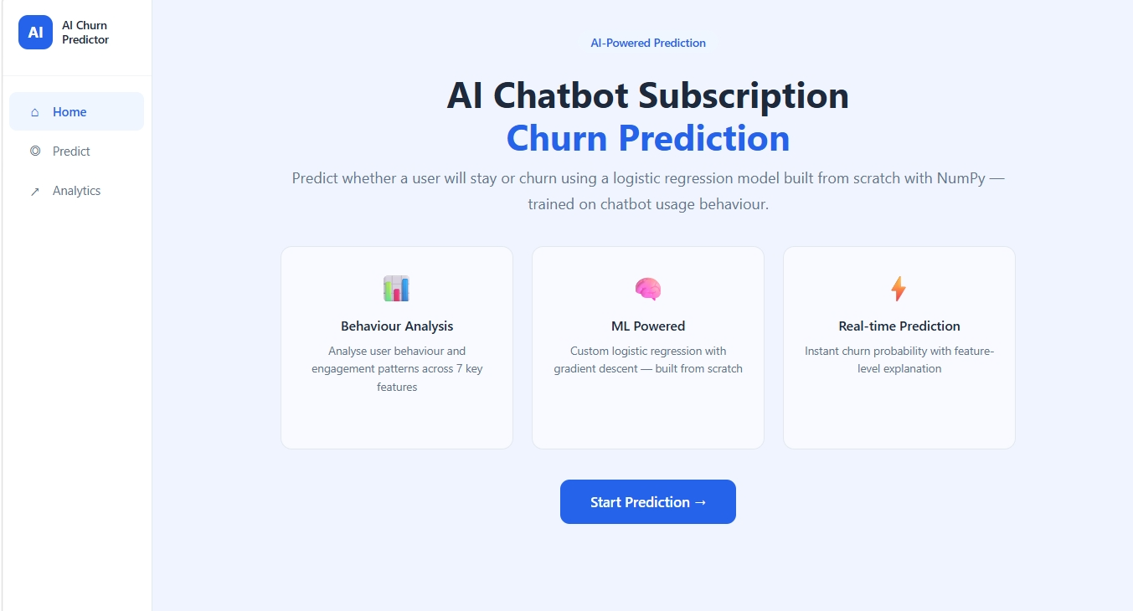

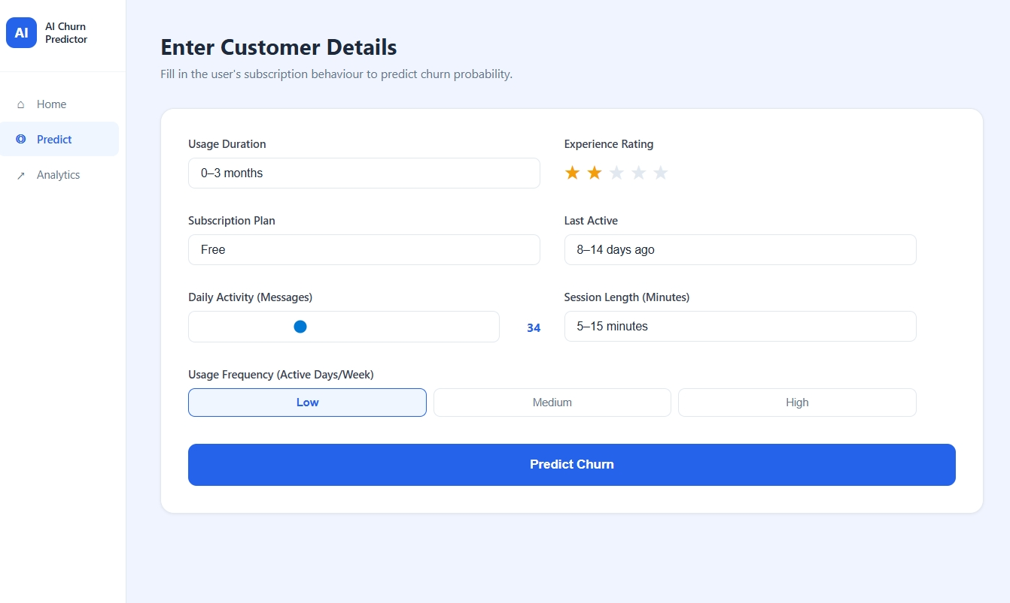

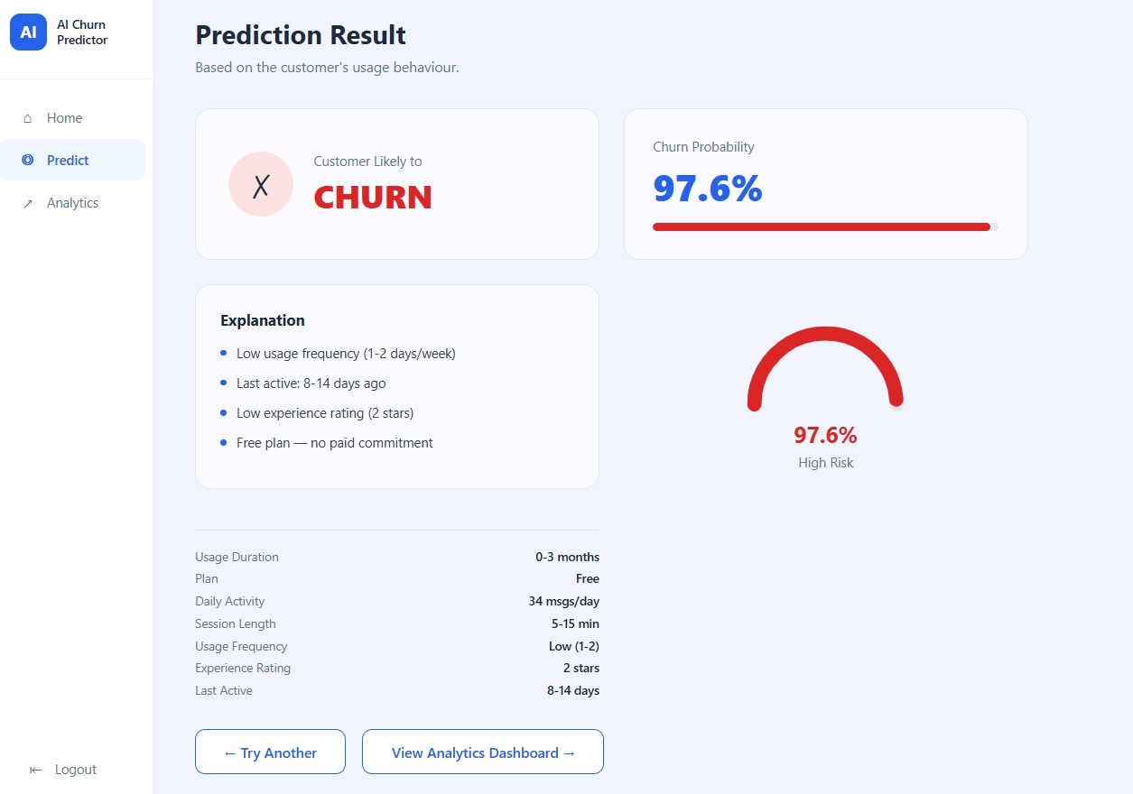

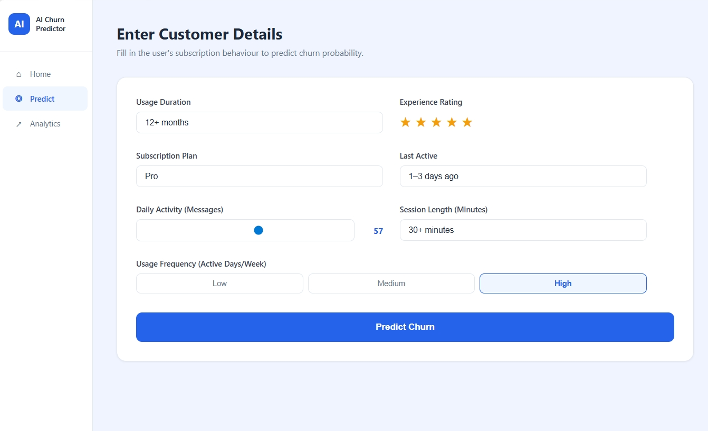

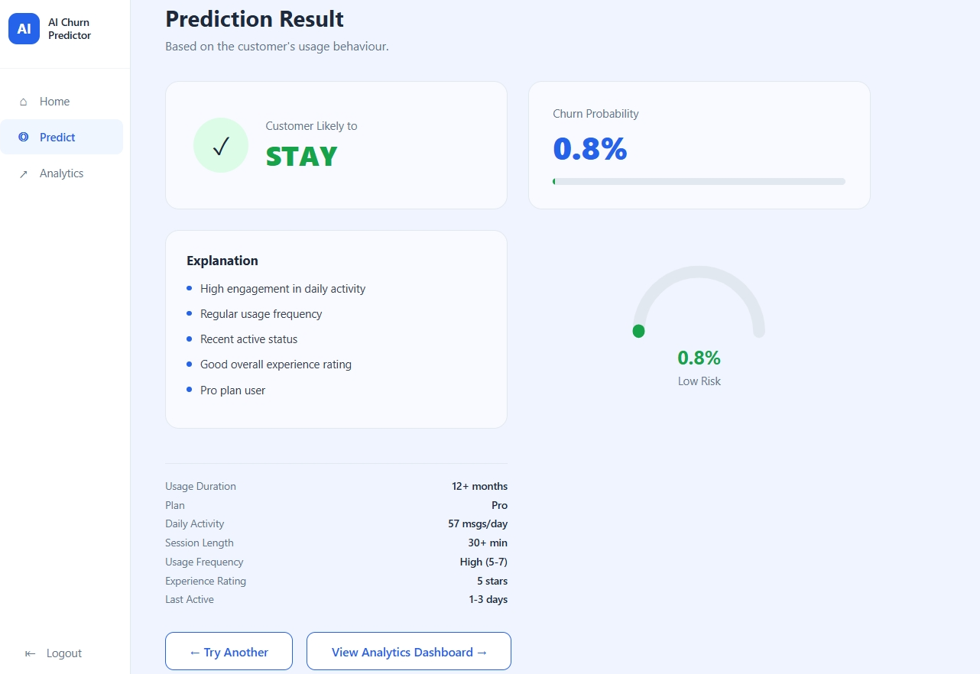

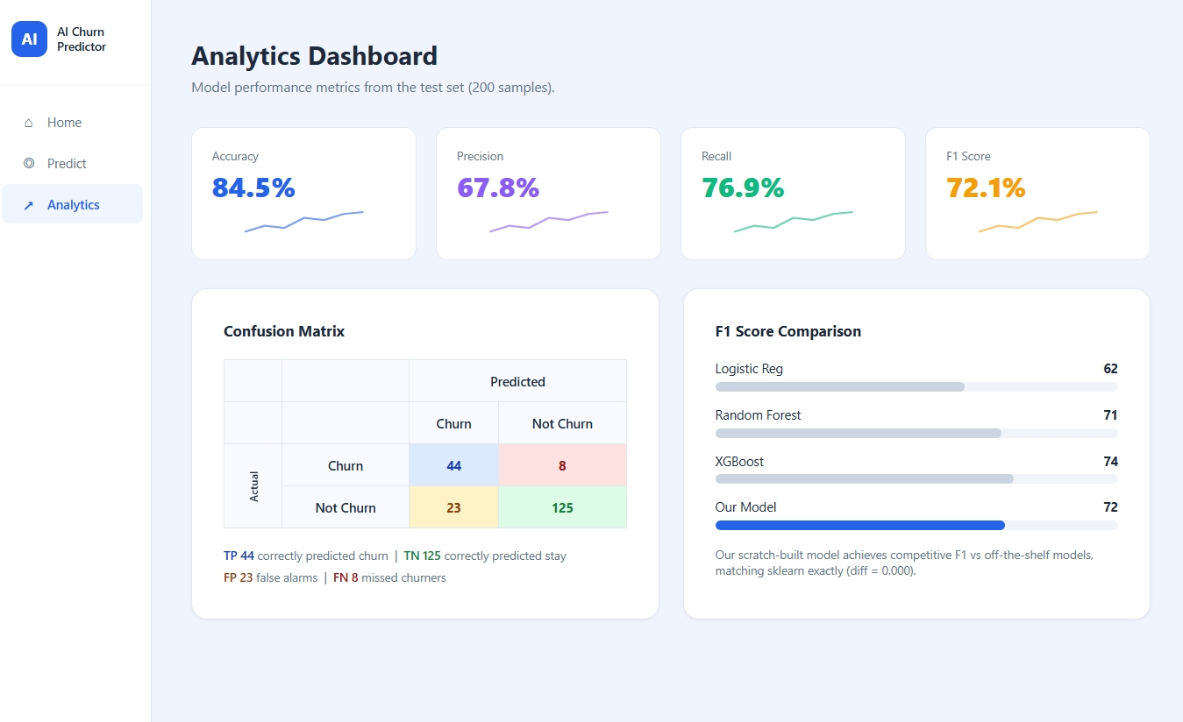

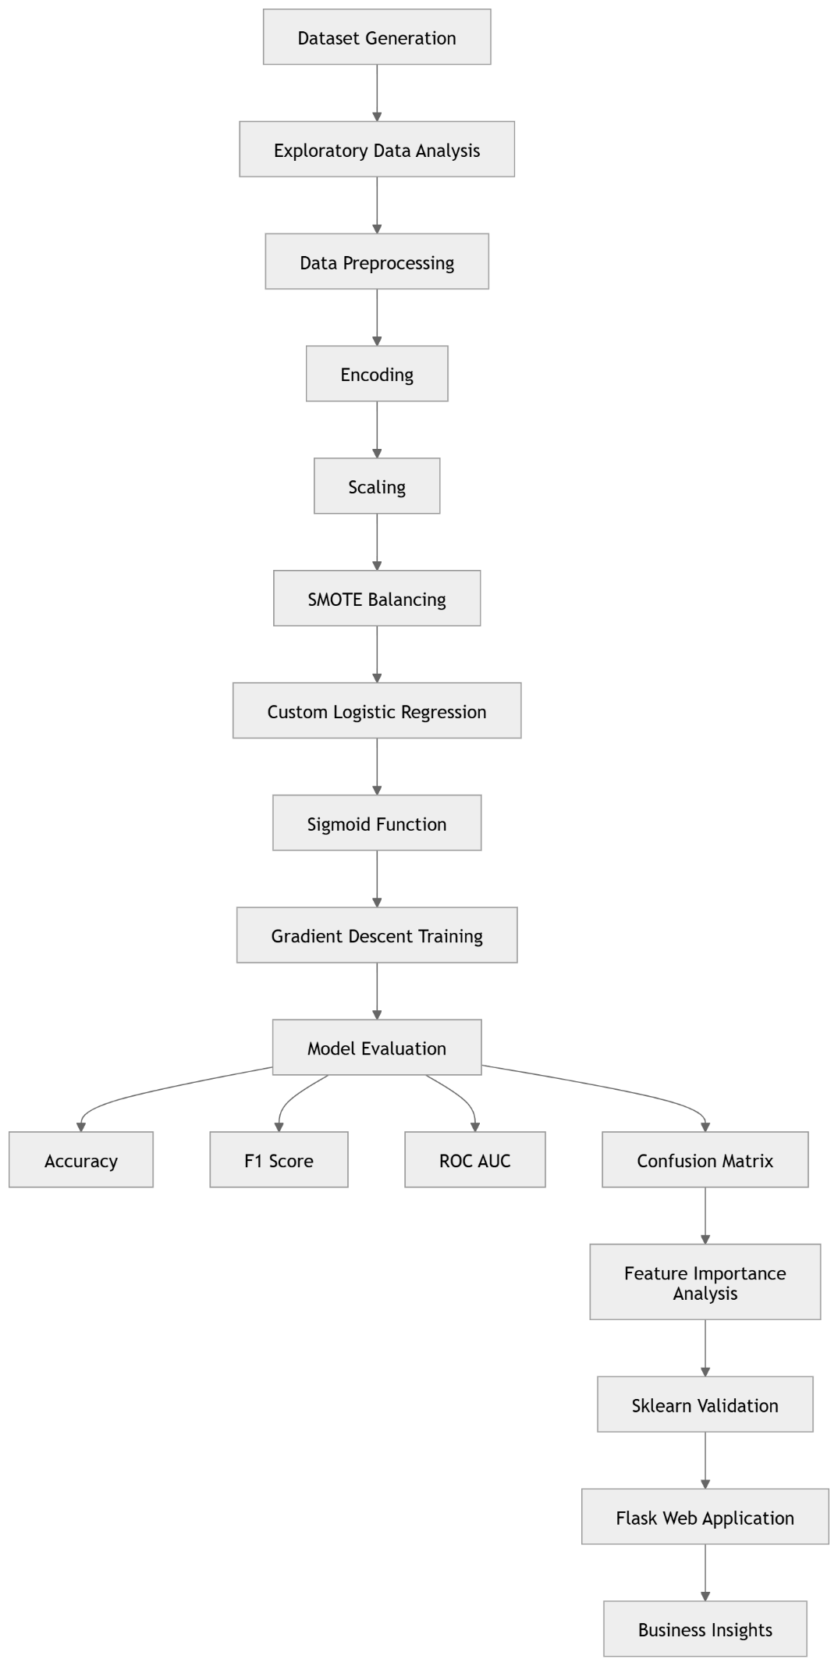
WORKFLOW
6.Sklearn Benchmark

To verify the accuracy of the custom model, the same data was also trained using sklearn's ready-made LogisticRegression, and the results were compared side by side. The difference was exactly 0.000 across all five metrics — Accuracy, Precision, Recall, F1 Score, and ROC-AUC — meaning both models gave the exact same predictions and the exact same scores on every single one of the 200 test users.
This only happens when everything in the custom code is mathematically correct. Sklearn uses a highly advanced internal solver to find the best possible weights. The custom model uses simple gradient descent — taking small steps downhill over 1,000 iterations — and still arrived at the exact same final weights as sklearn. This is only possible if the three core components were all coded without any error: the sigmoid function that converts scores into probabilities, the log-loss formula that measures how wrong the model is, and the gradient update rule that adjusts the weights at each step. Even one small mistake in any of these three would have produced different weights and different results.
This is the best possible proof that the from-scratch model works correctly. The result is not "close to sklearn" or "almost matching" — it is completely identical. This means the project does not just show an understanding of logistic regression on paper, but actually proves it by producing the exact same mathematical answer that professional machine learning software produces — using nothing but NumPy.
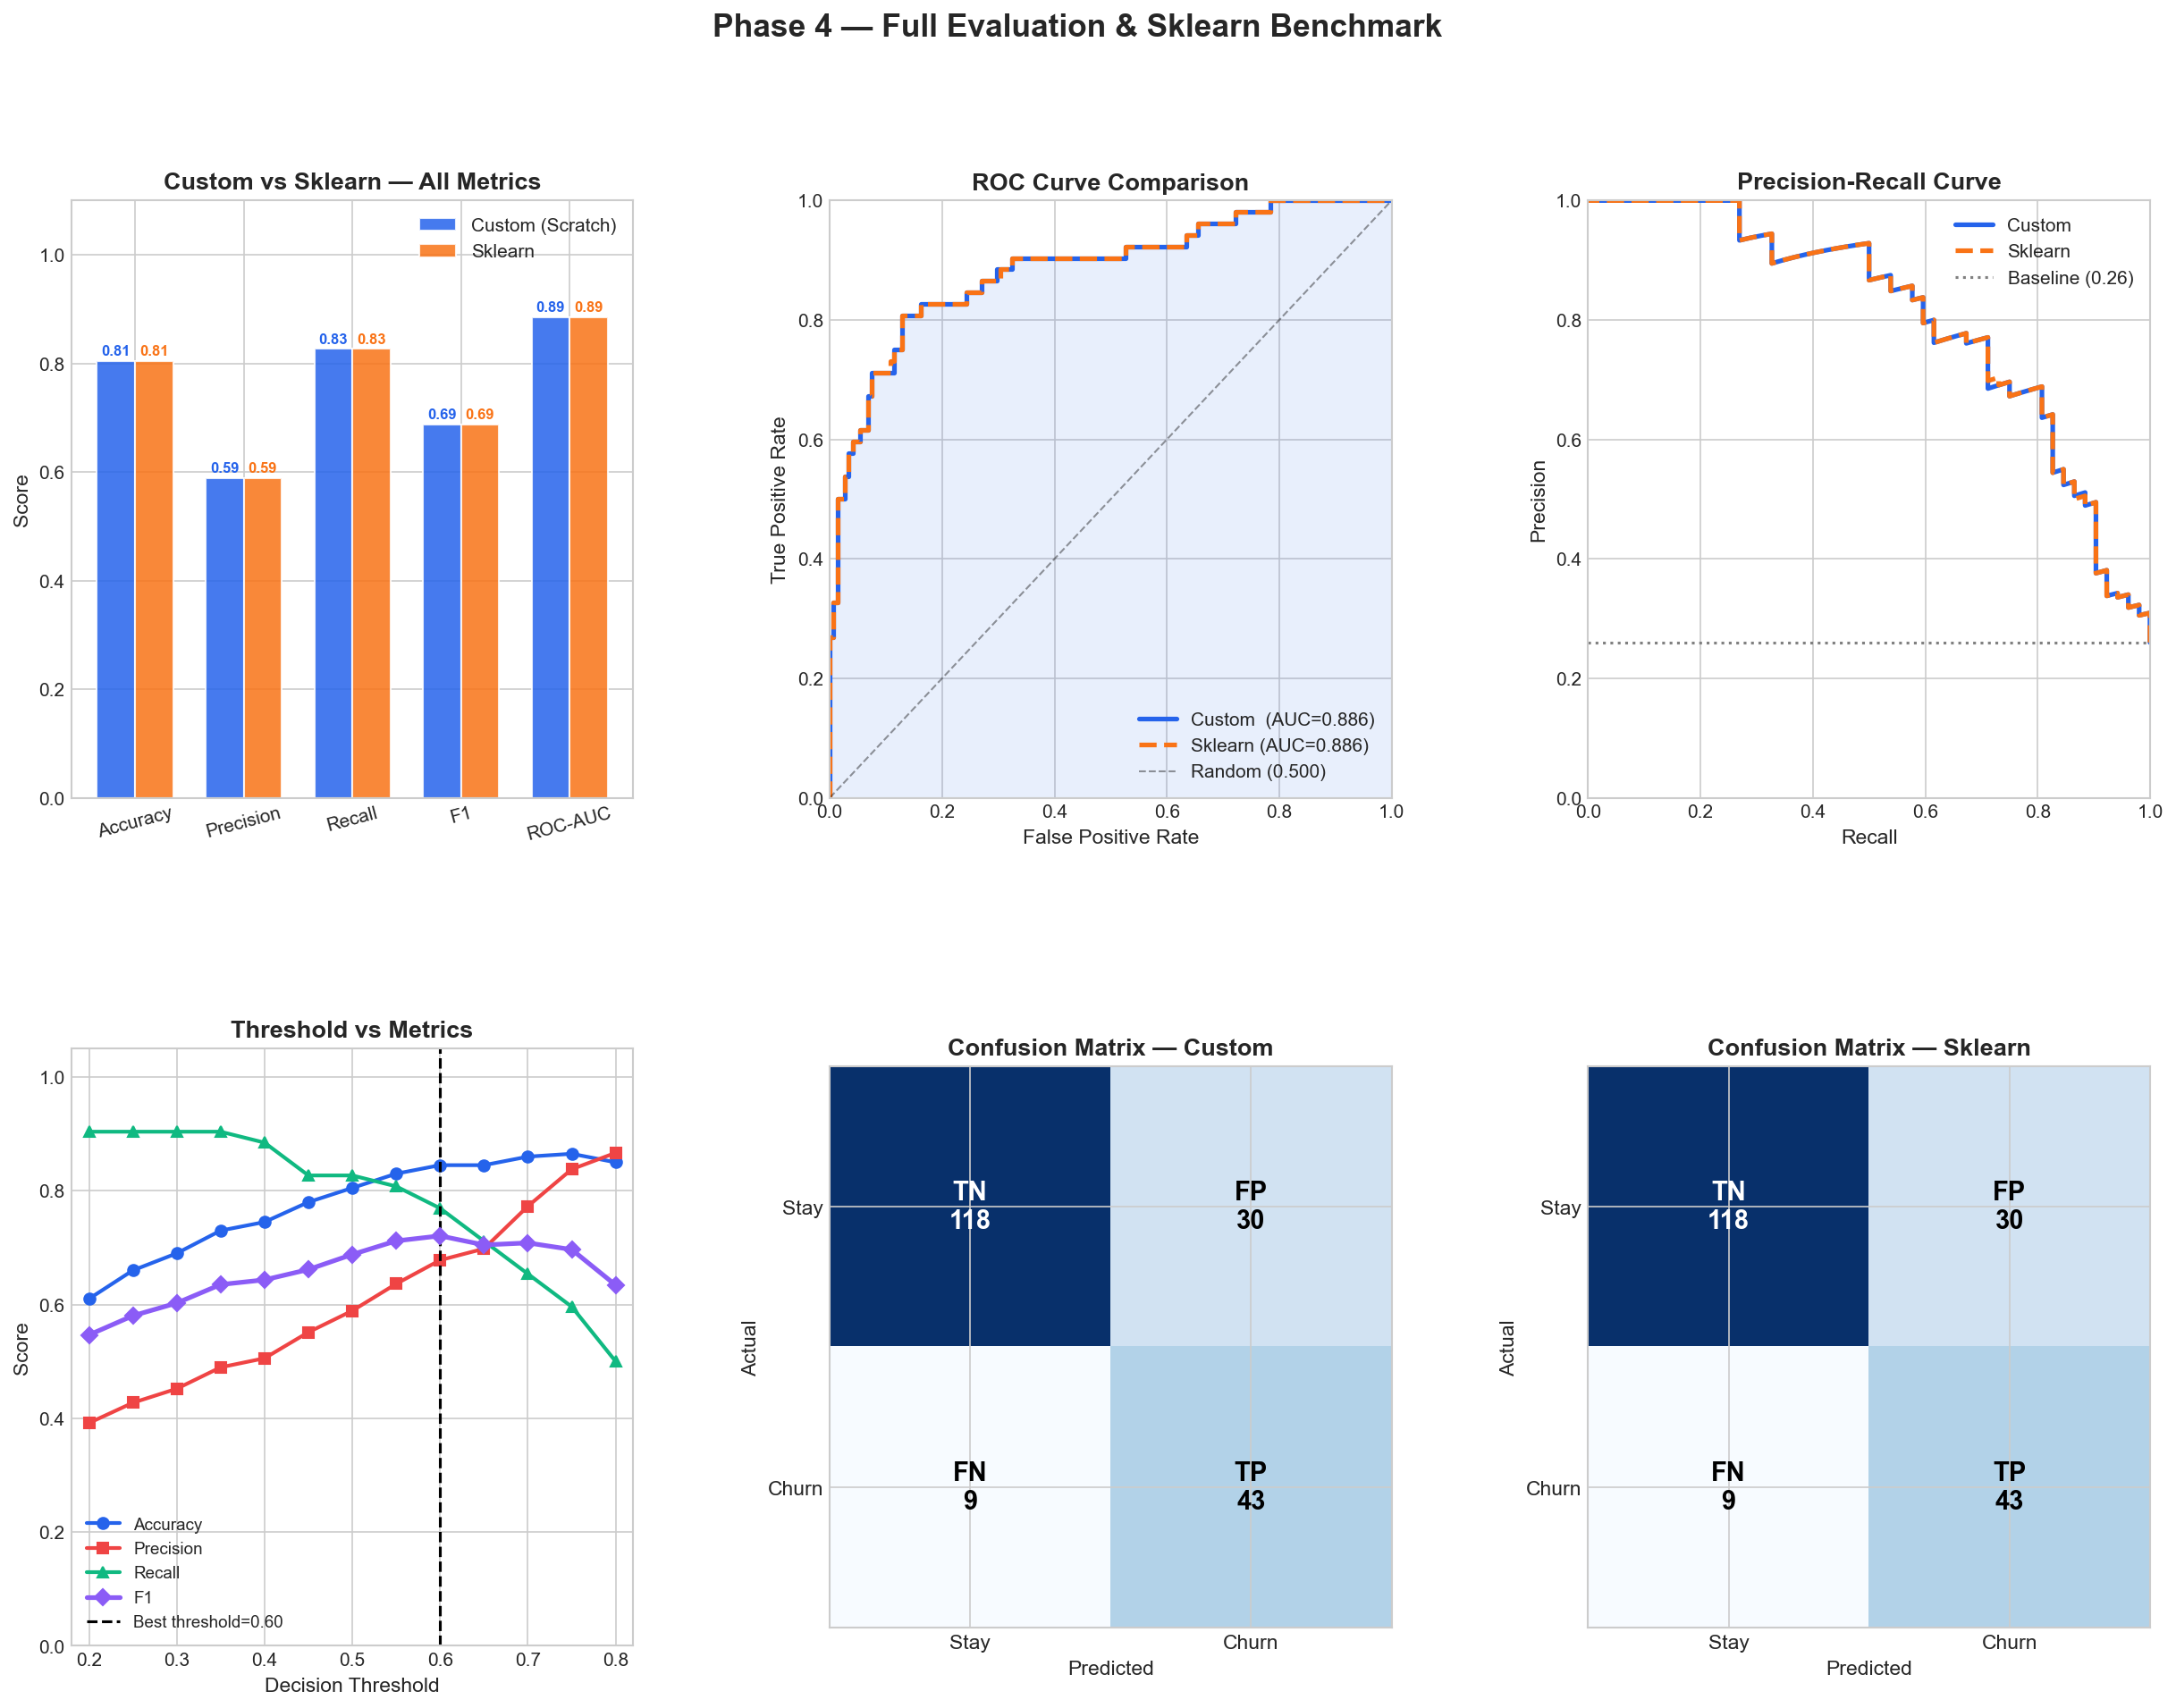
The six charts above confirm that the custom model and sklearn produced identical results across every evaluation measure, with both confusion matrices showing the exact same predictions on all 200 test users.
Chart | What it proves
Custom vs Sklearn bar chart | Shows 0.000 difference visually — every bar is identical
ROC Curve Comparison | Both lines sit on top of each other — AUC 0.886 for both
Precision-Recall Curve | Both curves overlap perfectly across the full range
Threshold vs Metrics | Shows why 0.60 was chosen — F1 peaks exactly there
Confusion Matrix Custom | Your model's exact predictions
Confusion Matrix Sklearn | Identical to yours — TN 118, FP 30, FN 9, TP 43

7. Feature Importance & Business Insights

When the model finished training, it assigned a weight to every feature. These weights show how much each feature influenced the prediction.
- Large positive weight → feature strongly predicts churn
- Large negative weight → feature strongly predicts stay
- Weight close to zero → feature had very little influence

Feature Weight Table
Rank | Feature | Weight | Direction | Strength
1 | Last Active | +1.187 | → Churn | Strongest
2 | Experience Rating | −1.055 | → Stay | Very Strong
3 | Subscription Plan | −0.918 | → Stay | Strong
4 | Daily Activity | −0.825 | → Stay | Strong
5 | Usage Frequency | −0.564 | → Stay | Moderate
6 | Session Length | −0.136 | → Stay | Weak
7 | Usage Duration | −0.034 | → Stay | Negligible

Last Active (+1.187) — Strongest Indicator of Customer Churn
Model Insights
- Inactivity was the strongest churn signal.
- Users inactive for long periods were more likely to churn.
- Churn probability increased as inactivity increased.
- Recent activity strongly reduced churn risk.
Business Insight
Businesses should monitor inactive users closely and send reminder notifications or re-engagement emails before users completely stop using the platform.

Experience Rating (−1.055) — Strongest Indicator of Customer Retention
Model Insights
- Higher ratings were strongly linked to customer retention.
- Low-rated users had a much higher churn rate.
- Customer satisfaction directly affected churn probability.
- Positive user experience reduced churn risk.
Business Insight
Businesses should quickly respond to dissatisfied users, improve chatbot quality, and resolve complaints early to reduce customer loss.

Subscription Plan (−0.918) — Paid Users Show Higher Retention
Model Insights
- Paid users were less likely to churn than free users.
- Enterprise users had the lowest churn rate.
- Higher subscription commitment improved retention.
- Free users showed the highest churn risk.
Business Insight
Encouraging free users to upgrade through discounts or premium trials can improve both revenue and customer retention.

Daily Activity (−0.825) — Higher Engagement Reduces Churn
Model Insights
- Highly active users had lower churn probability.
- Low activity showed weak engagement.
- Regular chatbot interaction improved retention.
- Daily usage helped users find more value in the platform.

Business Insight
Businesses should encourage users to interact more with the chatbot through onboarding campaigns, feature recommendations, and activity reminders.

Usage Frequency (−0.564) — Regular Usage Builds Customer Habits
Model Insights
- Frequent platform usage reduced churn risk.
- Users active more days per week were more likely to stay.
- Regular usage helped build long-term habits.
- Low-frequency users were more likely to leave the platform.
Business Insight
Weekly reminders, notifications, and personalized suggestions can encourage consistent usage and improve customer retention.

Session Length (−0.136) — Minor Influence on Churn Prediction
Model Insights
- Session length had only a small impact on churn prediction.
- Longer sessions were slightly associated with retention.
- It was not a strong behavioural indicator.
- Other features contributed more significantly to predictions.
Business Insight
Session length should be treated as a supporting feature rather than a major churn indicator.

Usage Duration (−0.034) — Least Important Prediction Feature
Model Insights
- Subscription duration had very little impact on churn prediction.
- Long-term users could still churn if engagement decreased.
- User behaviour mattered more than account age.
- The feature contributed very little to the model.
Business Insight
Businesses should focus more on user activity and satisfaction rather than assuming older users will always remain loyal.

8. Conclusion
This project successfully developed a customer churn prediction system for chatbot subscription platforms using a Logistic Regression model built completely from scratch with NumPy. The model achieved strong performance with a ROC-AUC score of 0.886 and an accuracy of 84.5%. The custom model also produced results identical to Scikit-learn’s LogisticRegression model, proving that the implementation was mathematically correct and reliable.
The project showed that user inactivity and low experience ratings were the strongest reasons behind customer churn. Users who stayed inactive for many days, used free plans, or interacted less with the chatbot were more likely to leave the platform. These insights can help businesses take early actions such as sending reminders, improving customer support, and increasing user engagement to improve customer retention.
In the future, this system can be improved by using real customer data from chatbot platforms. Additional features like payment history, support tickets, and feature usage can help improve prediction accuracy further. The model can also be retrained regularly and integrated into real-time business systems to provide continuous churn monitoring and better customer retention strategies.

